Lab: Using Javadoc comments and Javadoc.exe

Step1

Insert the required Javadoc comments into your java files

Example

/**This is an instantiable Student class.

@author John Walsh

@version 1.0 */

public class Student {

//attributes

private String name;

private boolean studentStatus;

/** single argument constructor method

@param name the full name of the student */

public Student(String name){

this.name=name;

studentStatus=true;

}

/** acessor method to return the student name

*@return the name of the student */

public String getName(){return name;}

/** mutator method to set the student name

*@param name the name of the student */

public void setName(String name){

this.name=name;

}

/** toString method to return the student details

*@return the name and status of the student as a string */

public String toString(){

return "Name: "+getName()+"Student: " +studentStatus;

}

}//end class

Step2

Setting the environment variable:

Go to control panel🡪System and security🡪System🡪Advanced System Settings

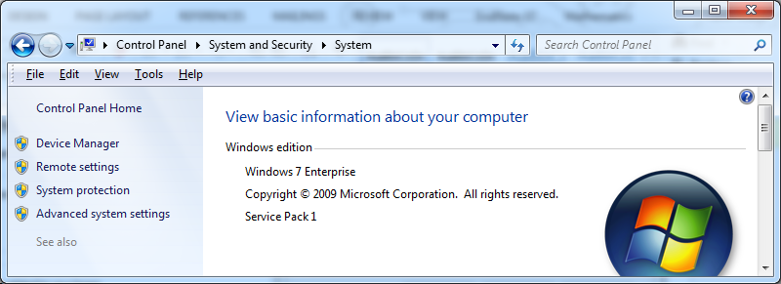

Go to Environment Variables🡪 **Edit** the **System variables** by adding an additional path to the **PATH** variable. The additional path should be similar to **C:\Program Files\Java\jdk1.8.0_05\bin**

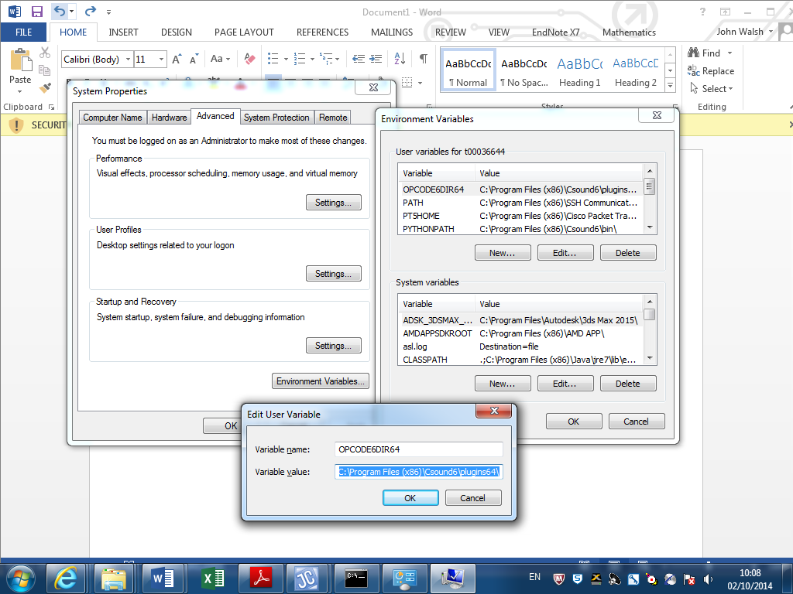

Step 3:

Enter cmd at the

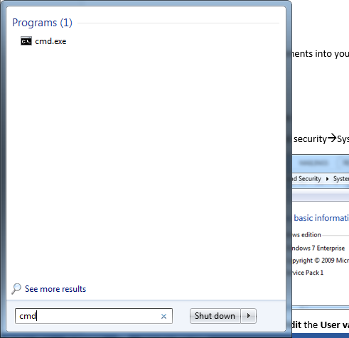

Change directory to directory containing java file:

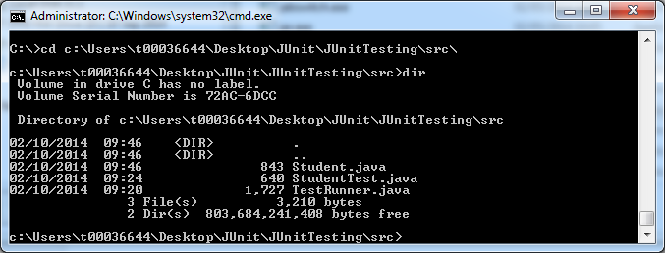

Step 4: Run javadoc



This should create some new html files:

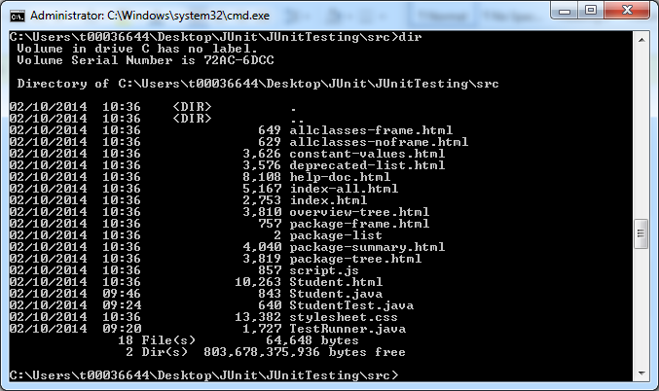

View the html file: Examine this file. It should look something similar to:

